# Bean and its Lifecycle – Udemy Url - [Notebook](https://notebook.zohopublic.in/public/notes/bietv2018487e1de84b009904a4dfeda24def)

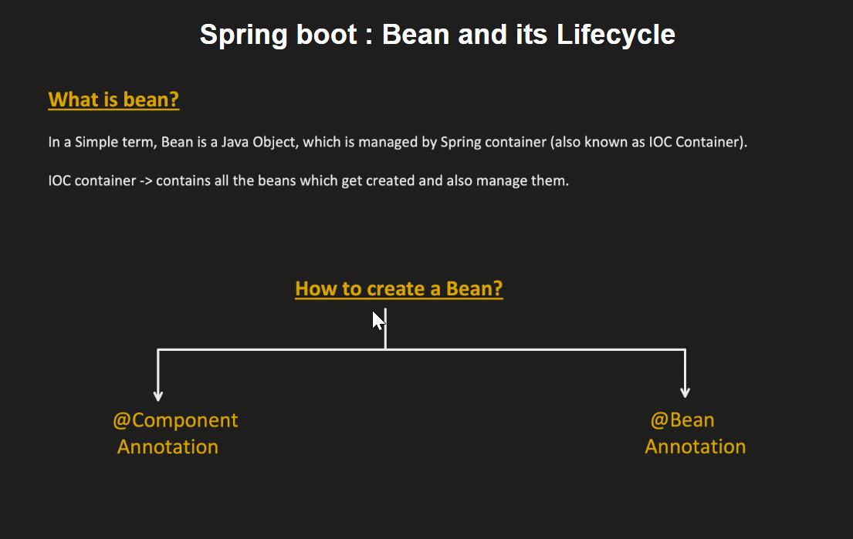

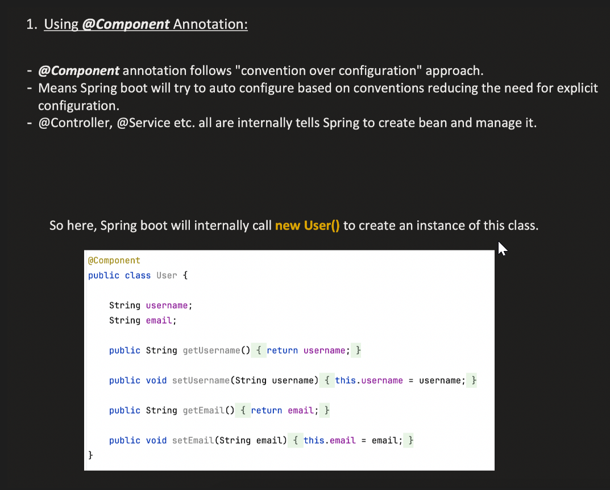

Here we have our own parameterized constructor. And java will not create a default constructor due to this. And springboot will now be able to call it’s default constructor.

Or if package is not defined than the package where the launcher class is present and it’s sub-packages.



